2025 TERM 1 MZIMBA NORTH DISTRICT EXAMINATIONS

MATHEMATICS FORM 4

PAPER I
(100 MARKS)
9th Dec, 2025
SUBJECT NUMBER: M131/I
TIME ALLOWED: 2 HOURS
INSTRUCTIONS

- This paper has 11 pages. Please check.
- The maximum number of marks for each answer is indicated against each question.
- Write your answers in the spaces provided
- Calculators may be used and all working should be clearly shown.
- Please make sure that you write your examination number and class on top of all pages in this paper before you start answering questions.

Questions  Answered | Tick if  Answered | Do not write in this column
1
2
3
4
5
6
7
8
9
10
11
12
Total

©MZN-T1-2025
Turn over/...
- Factorise completely; $x^{2}+7x+6$ (3marks)

- Evaluate; $\log_{2}\{\log_{3}\left(\log_{5}125\right)\}$ (4 marks)

- Given that p and q are two matrices if P =$\left({0 \atop -1} {3 \atop 1} \right)$ and Q = $\left({2 \atop -1} {1 \atop 3} \right)$ find 3P- $Q^{2}$
(5 marks)

- The following are six marks in a test, 4, 9, 3, 4, m, 9. If the mean mark was 6.5. Find m. (4 marks)

- AB is a diameter of a circle. The tangent at a point P is such that angle APT =${112}^{0}$
Calculate angle BAP? (5 marks)

- a. Solve for x; $2^{x}+ 2^{5} =33$

(4 marks)

b. If $f\left(x\right)=8^{x}-6. Find f\left(\frac{2}{3}\right)$
(4 marks)

- The figure1 below shows the region D bounded by three inequalities

6
5 (3,5)
4 D
3 (1,3)
2
1 (4,1)
1 2 3 4

Calculate the maximum value of 5x-4y+8 (5 marks)

- Simplify $\frac{1}{√2}-\frac{√2}{3}$ leaving your with rational denominator. (4 marks)

- Calculate the variance and standard deviation of the following numbers (g+8), g, and (g-8) (6 marks)

- Make x the subject of the formula $V=W\sqrt{a^{2}-x^{2}}$ (4 marks)

- Simplify into a single fraction $\frac{1}{x-1}+\frac{3y}{xy-y}$ (5 marks)

- Without plotting the graphs, find the points of intersection for the following equations $y=x^{2}-4x+5$ and $y+2x=8$
(6 marks)

- An arithmetic Progression (AP) has first term 3 and common difference 2. Find the sum of the first 80 terms.
(6 marks)

- A car from rest attains a velocity of 15m/s for the first 4 seconds, it maintains the speed for 6 seconds then decelerates uniformly for 5 seconds. Calculate total distance covered for the journey. (5 marks)

- A straight line passes A(4, -1) and B(3, -1). Find the distance of the line AB.
(5 marks)

- Find the equation of a curve in form of $y={ax}^{2}+bx+$c ,crossing the x-axis at points -1 and 3 with y-intercept -3 (4 marks)

- Draw triangle ABC with vertices A(-3,1), B(-1,1), C(-2,3) and it image using (0,0) as centre of enlargement and scalar factor 2. (6marks)

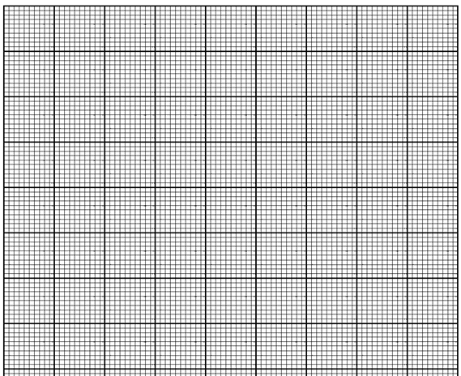

- A church tower is 80m high. Find the angle of elevation of its top from a point on the ground 150m away on the level ground
(5 marks)

- Without using a calculator or tables, evaluate $SinA=0.6 find CosB$ (4 marks)

- Solve for b $2{\left(b+1\right)}^{2}-2=0$
(6 marks)

END OF QUESTION PAPER

